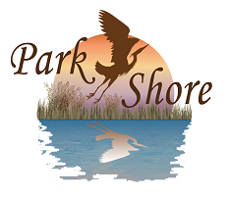

2023 Park Shore Association Directory
Advertising Authorization Form

(Please print clearly - fill out all information)

BUSINESS NAME: _________________________________________________________

ADDRESS: _______________________________________________________________

PHONE: _______________________

CONTACT PERSON: _________________________________________

(Please check one)
AD SIZE: [ ] Center Quarter Page ($375) [ ] Center Half Page ($750) [ ] Center Full Page ($1,000)
( 5” x 2”) (5” x 4”) (5” x 8”)

AMOUNT ENCLOSED $_____________ (Checks to be made out to: Park Shore Association)

ADVERTISEMENT: (Include business logo, photo or other message) Camera-ready artwork, if possible. No staples, please. If you have camera ready artwork, please e-mail it directly to Clay W. Cone, Executive Director for the Park Shore Association, at parkshoreassoc@gmail.com.

Deadline for ads is Friday, December 2, 2022

Mail payment & form to: Park Shore Association
Attn: Directory Advertising
P.O. Box 1435
Naples, FL 34106-1435

